**CIS 667 Semester Project Report**

**Dots and Boxes**

**Team Members:**

Husen Bhagat – habhagat

Kartheek Sunkara - sasunkar

Pranav Kulkarni – pjkulkar

Sreekar Sykam Reddy – ssykam

**Introduction:**

We have implemented a 3-player version of the dots and boxes game.

The game starts with an empty grid of dots of size n x n which is specified by the user.

TODO

Tree Search algorithm:

Machine learning algorithm:

Results:

**Github link:** <https://github.com/husenbhagat/DotsAndBoxes3v3>

**Game:**

We have implemented a 3 player version of the Dots and Boxes game. This game starts with an empty grid of dots of size n x n, where n is specified by the user. In this implementation 3 players take turns to add a single horizontal or vertical line in the grid, between two dots which are already not joined. Any player who completes the fourth side of the box earns one point and then takes another turn. The game will end when there are no more lines which can be placed in the grid and the player with maximum points wins the game. [1]

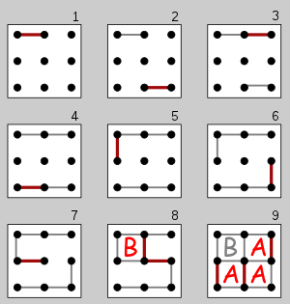

Image taken from Wikipedia

**Representation and state of game:**

To represent the game state, we have created a class Box, which stores the state of the four edges.

Another class Game represents the entire board by storing instances of Box class.

For the convenience of using this data for tree search and machine learning algorithms, we convert this game state into a list which can represent a game state with the following values:

0 -> edge does not exist

1 -> edge exists

**Valid actions:** At each turn, a valid action by a user would be to select one of the free vertical or horizontal edges. If the user selects a 4th edge which completes a box, the user is awarded one point, and gets another turn.

Game is over when no free edges are left in the grid. The player with maximum points is declared as the winner of the game.

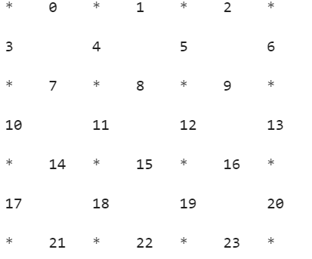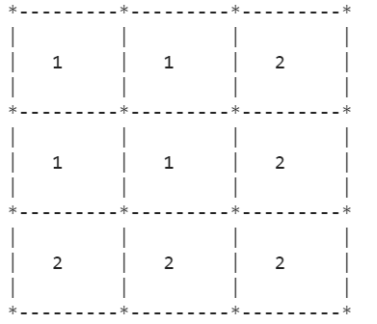

1. Initial state of the game
2. Winning state of the game

Game board sizes:

We can vary the game board by providing different number of rows and columns as follows:

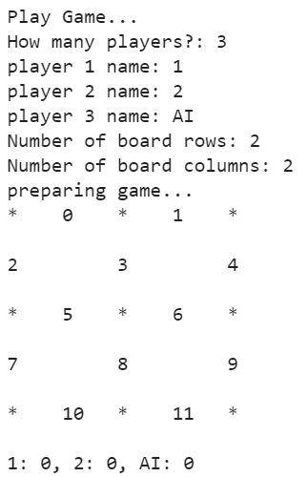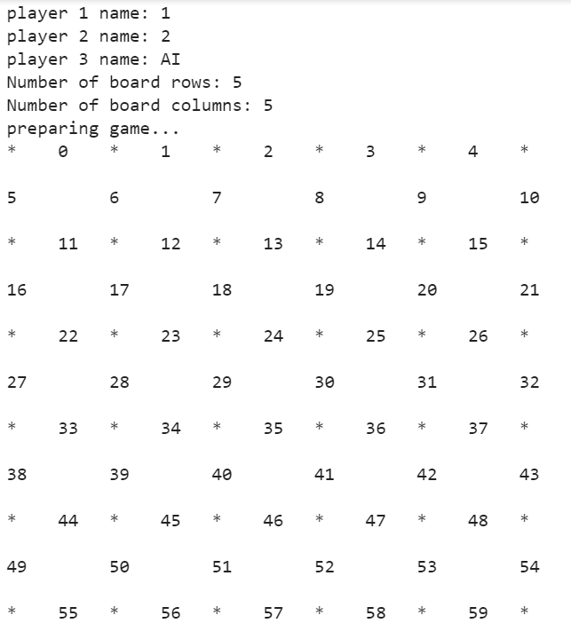

1. 2 x 2 game board
2. 5 x 5 game board

**Tree Search:**

We have used minimax tree search in our implementation of dots and boxes.

Minimax is a backtracking algorithm used in game theory to find the optimal move for a given player, provided the other player also plays optimally. [2]

The traditional minimax works for 2 player: one trying to maximize its score and the other trying to minimize the opponent’s score. We have altered minimax to work for 3 players where the AI competes with the player who plays optimally (Detailed explanation of this works is given below).

**Branching factor: Number of open edges in the game board**

**In worst case the branching factor would be all edges**

**= 2 * (rows * columns) + (rows + columns)**

**Number of nodes at each depth: Since minimax uses DFS to traverse the search space, the number of nodes at each depth would be the same as DFS i.e. (b-1) * (d) + 1**

**We used both limited depth and random sampling to restrict the size of the search tree.**

**Limited depth: 5, we have limited the depth to 5 because exploring the entire game state will take a lot of time as the number of game states is equivalent to the number of open edges in the game.**

**The utility of each leaf node will be evaluated by taking the difference between the scores of the players.**

**Random Sampling: Yes**

**Instead of just using random samples, we also use spatial locality of reference to prioritize the samples that we need to consider.**

**At every turn in minimax, we send the entire game state to our spatial locality of reference, where we assign a priority to each edge based on the winning chance. The priorities to edges are assigned as follows:**

**For the following game state:**

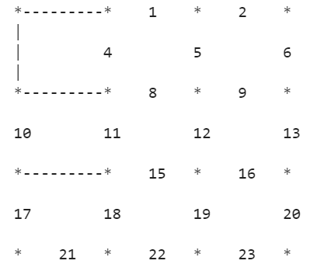 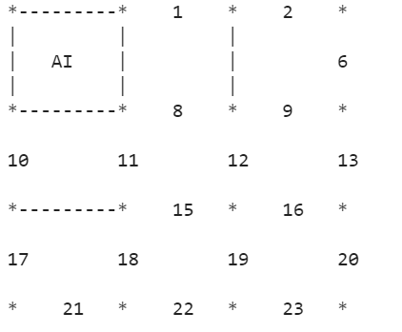 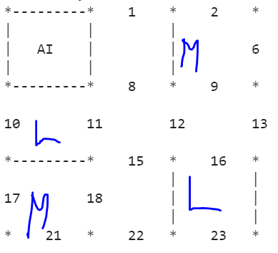

1. Instance of sampling with highest priority edge
2. 2. AI’s decision based on sampling
3. 3. Instance of sampling with medium and low priority edges

The spatial locality of reference would assign the highest priority to edge 4 as it’s box has 3 completed edges and only one open edge.

Taking this edge in sampling, the AI would select edge 4 and will earn a point when it completes the box as shown in figure 2 above.

The other edges are either prioritized as medium – where the box has 0/1 closed edges and as low – where the box has 2 open edges as shown in figure 3 above.

The spatial locality of reference also takes into account the impact of shared edges among boxes. For instance, when we are assigning a priority for edge 16, we will consider the boxes above and below which are shared by edge 16.

Code for minimax tree search:

Implementation of minimax for 3 players

The AI competes with the player with maximum score at a given instance.

For example consider the following scores for the 3 player for an intermediate state:

Player 1: 2

Player 2: 4

Player 3(AI): 10

In this case AI would compete and try to minimize Player 2’s score as shown in code below:

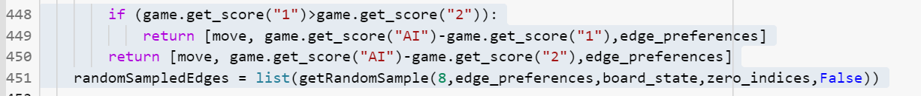

Code for minimax :

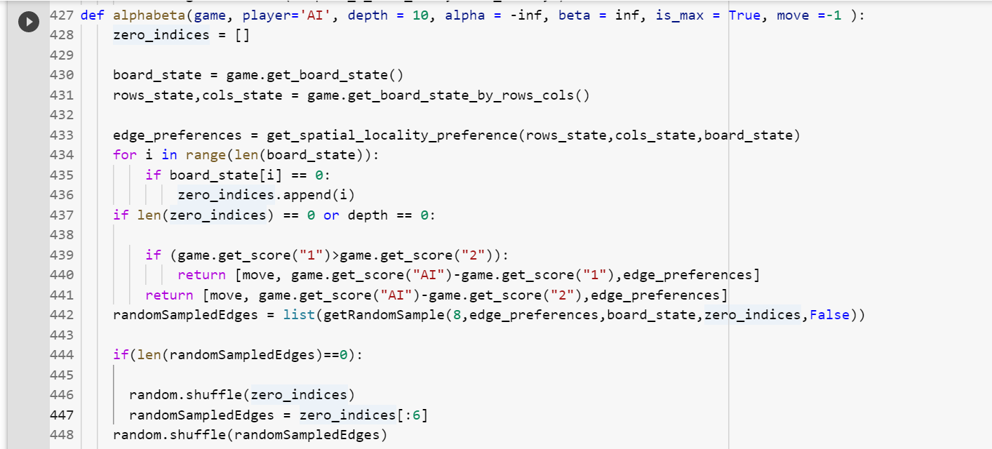

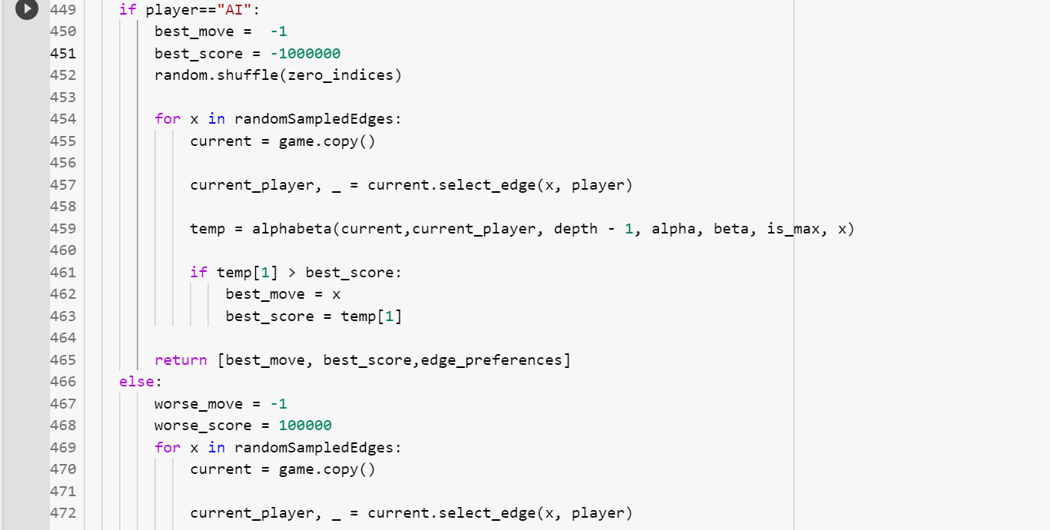

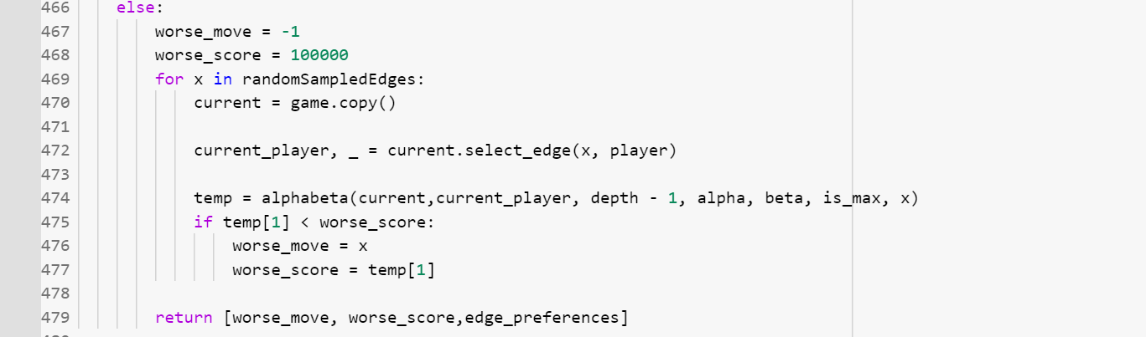

**Class Diagram for minimax implementation:**

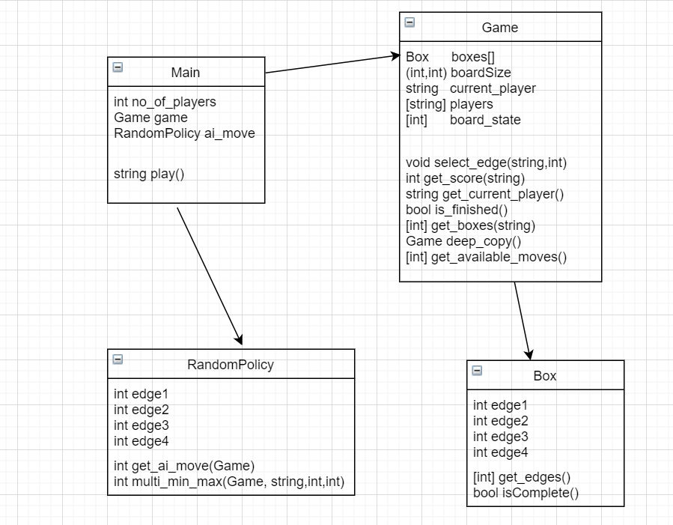

**Machine learning model:**

We have implemented neural network to train our model.

We used the following activation functions to fire the neurons or not.

1. ReLU (Rectifier Linear Unit)

**A(x) –> max (0, x)**

1. Tanh

Sigmoid formula = A = $\frac{1}{1+ e^{-x}}$

Tanh(x) = $\frac{2}{1+ e^{-2x}}-1$

**= 2 * sigmoid (2x) - 1**

Layers used in the nn.Squential:

We have used the number of input neurons, for input layer = number of edges

Number of neurons for hidden layer = (rows + columns)

Number of neurons for output layer = 5

Trainable parameters:

Number of neurons

Number of batches

Number of iterations

Learning rate

Number of hidden layers

**Generating and updating the training data:**

The flow of training the neural network is as follows:

1. For each batch:
   1. Declare a sample list and initialize it as empty
   2. For each iteration:
      1. Take starting state of the game
      2. Continue playing the game until it is over
         1. Assign an appropriate weight based on which player won the game
         2. Add this weight and maximum (neuralNetworkOuput) to the game state
      3. Take state + moves from each sample list along with the weights and max(neuralNetworkOutput) which is taken as a target to neural network.
      4. Train the neural network using above data.

**Conversion of game state into ML understandable data:**

To represent the game state, we have created a class Box, which stores the state of the four edges.

Another class Game represents the entire board by storing instances of Box class.

For using this data for neural network, we convert this game state into a list which can represent a game state with the following values:

0 -> edge does not exist

1 -> edge exists

After converting into list, neural network also needs the game score for each player as an input. For this, every time any player completes a box, we store which player marked the winning edge.

Depending on which player won the game we are assigning the weight, as mentioned in above algorithm (step 1.b.ii.2)

Finally, we are converting the entire data (game state, moves, weight values) into tensor units (tensor(np.array()))

TODO**:**

**Different model configurations:**

**Baseline Opponent:**

We have used 2 baseline opponents, to test this model.

**Baseline 1:**

We simply take the edge which is randomly generated from the available list of edges i.e. which are not marked yet.

**Baseline 2:**

Instead of just using random samples, we also use spatial locality of reference to prioritize the samples that we need to consider.

We sent the entire game state to our spatial locality of reference function, where we assign a priority to each edge based on the winning chance. The priorities to edges are assigned as follows:

**For the following game state:**

  

1. Instance of sampling with highest priority edge
2. 2. AI’s decision based on sampling
3. 3. Instance of sampling with medium and low priority edges

The spatial locality of reference would assign the highest priority to edge 4 as it’s box has 3 completed edges and only one open edge.

Taking this edge in sampling, the AI would select edge 4 and will earn a point when it completes the box as shown in figure 2 above.

The other edges are either prioritized as medium – where the box has 0/1 closed edges and as low – where the box has 2 open edges as shown in figure 3 above.

The spatial locality of reference also takes into account the impact of shared edges among boxes. For instance, when we are assigning a priority for edge 16, we will consider the boxes above and below which are shared by edge 16.

Among all the prioritized edges, the edge with the highest priority is chosen as the next move.

**Experimental Results:**

**Configuration 1 - Husen Bhagat – habhagat**

Model with Adam (adaptive learning rate optimization algorithm) & Tanh (Activation function):

n_batches = 25

n_reps_per_batch = 1600

n_iterations = 100

network = [2*rows+cols,cols]

learning_rate = 0.03

Game sizes: [2x2, 3x2, 3x3, 4x3, 4x4]

Output Screenshots:

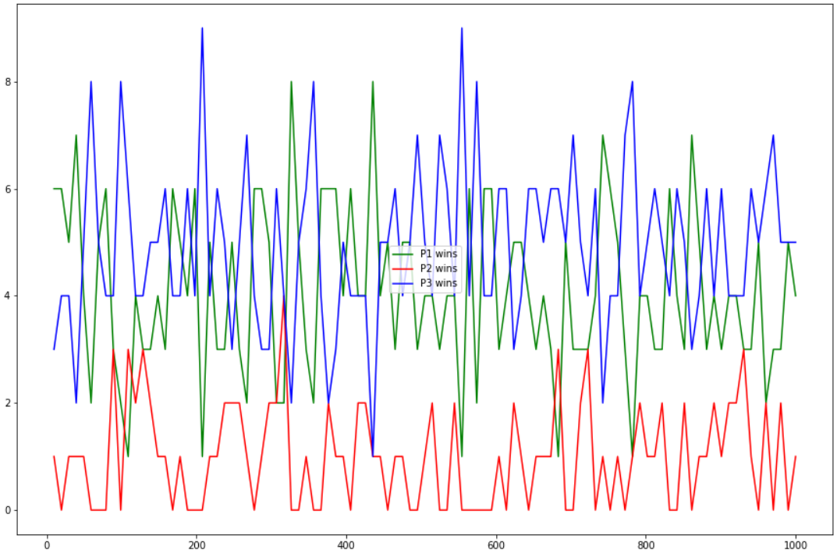

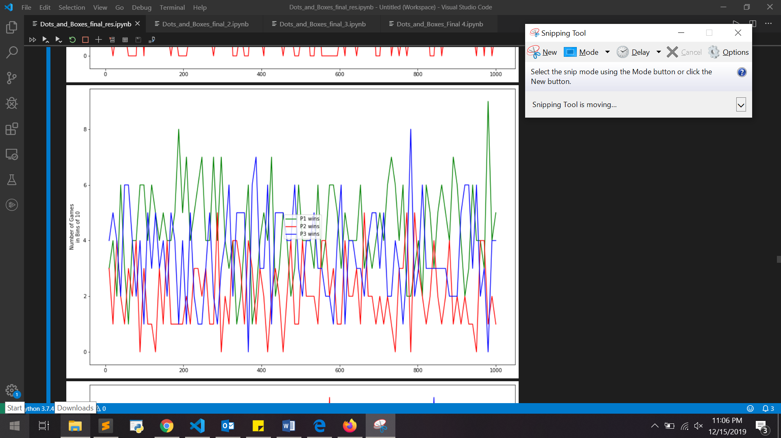

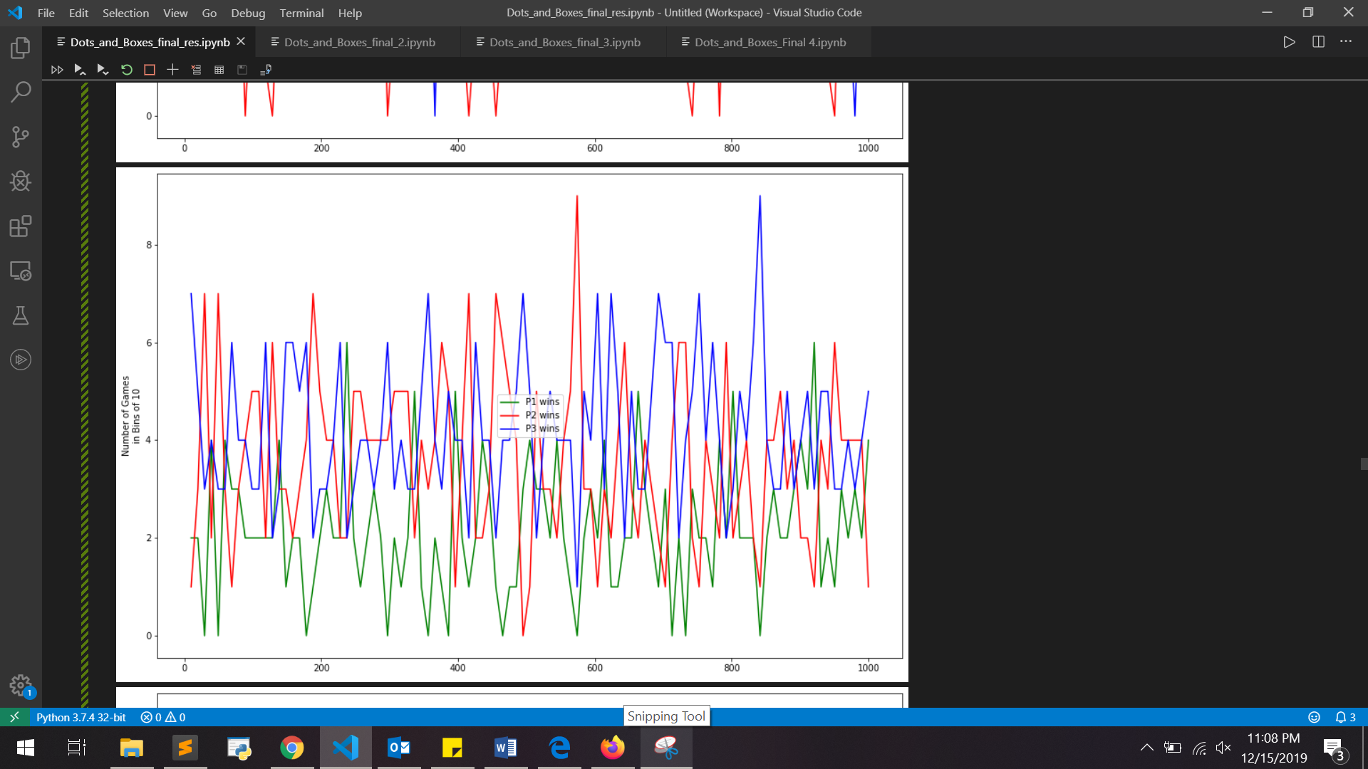

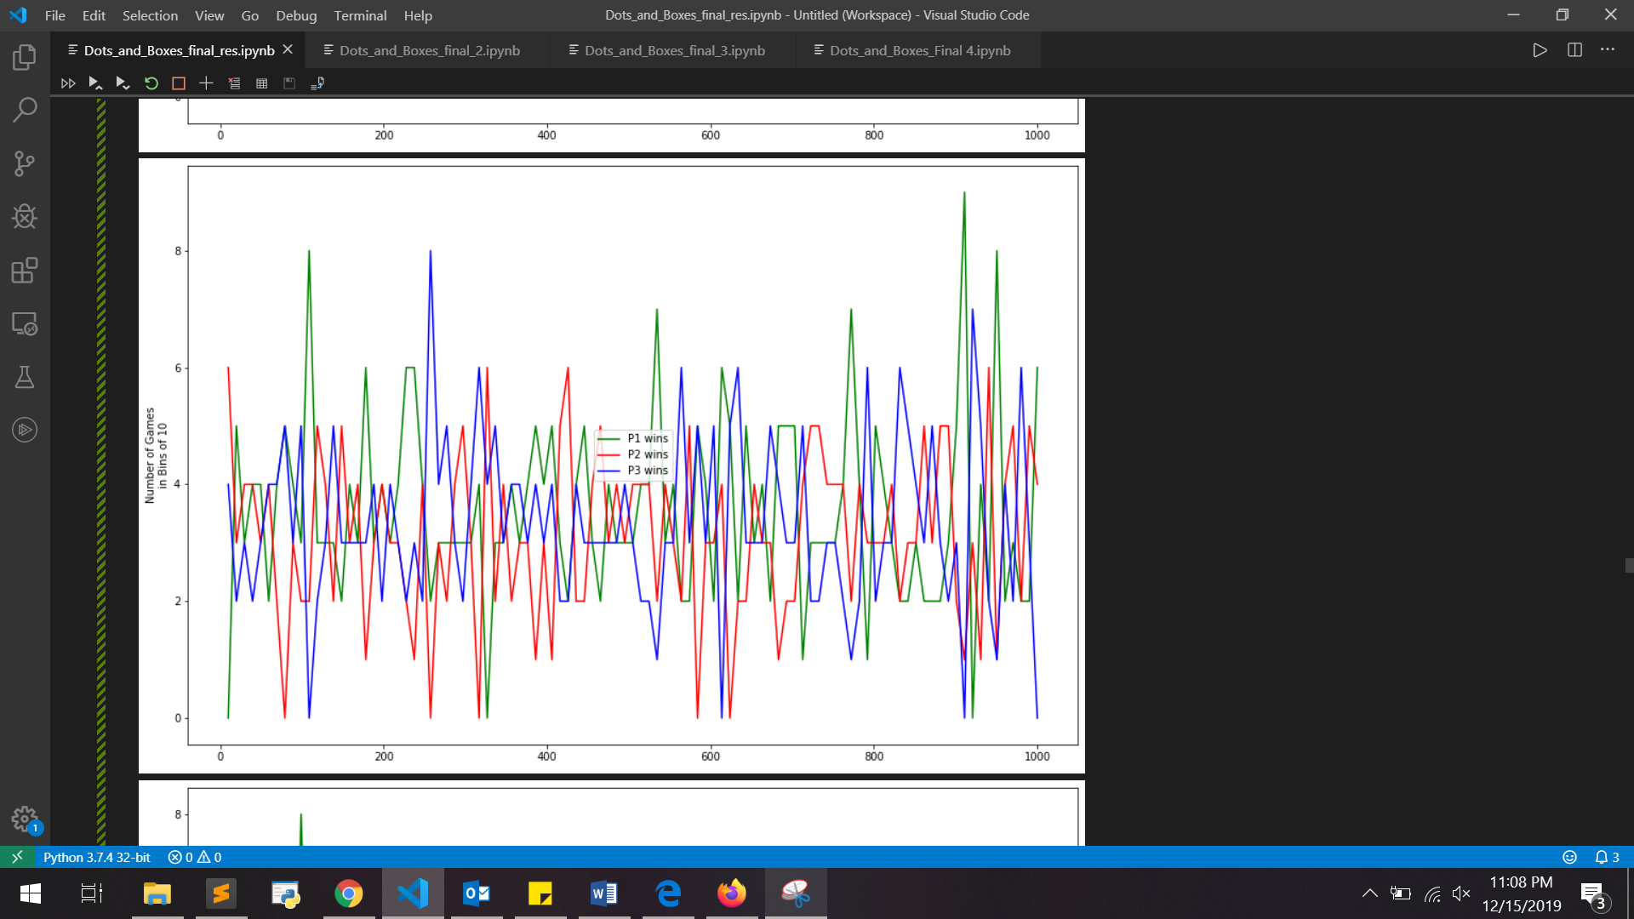

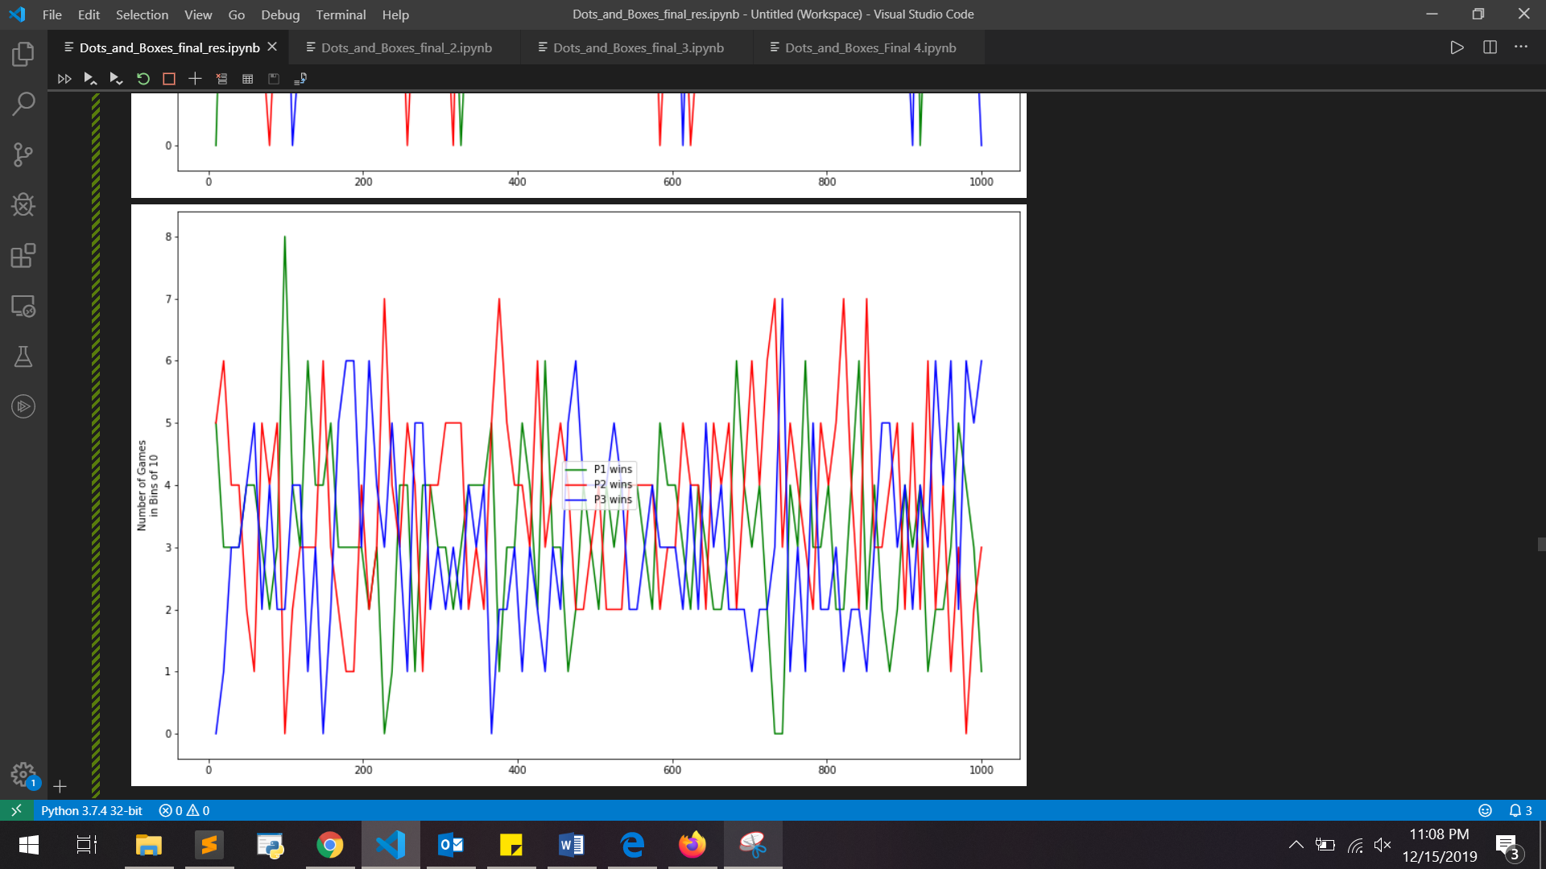

**Configuration 2 - Kartheek Sunkara – sasunkar**

Model with Adam (adaptive learning rate optimization algorithm) & ReLU (Rectified Linear Unit for activation function):

n_batches = 35

n_reps_per_batch = 1700

n_iterations = 150

network = [2*rows+cols,cols]

learning_rate = 0.04

Game sizes: [2x2, 3x2, 3x3, 4x3, 4x4]

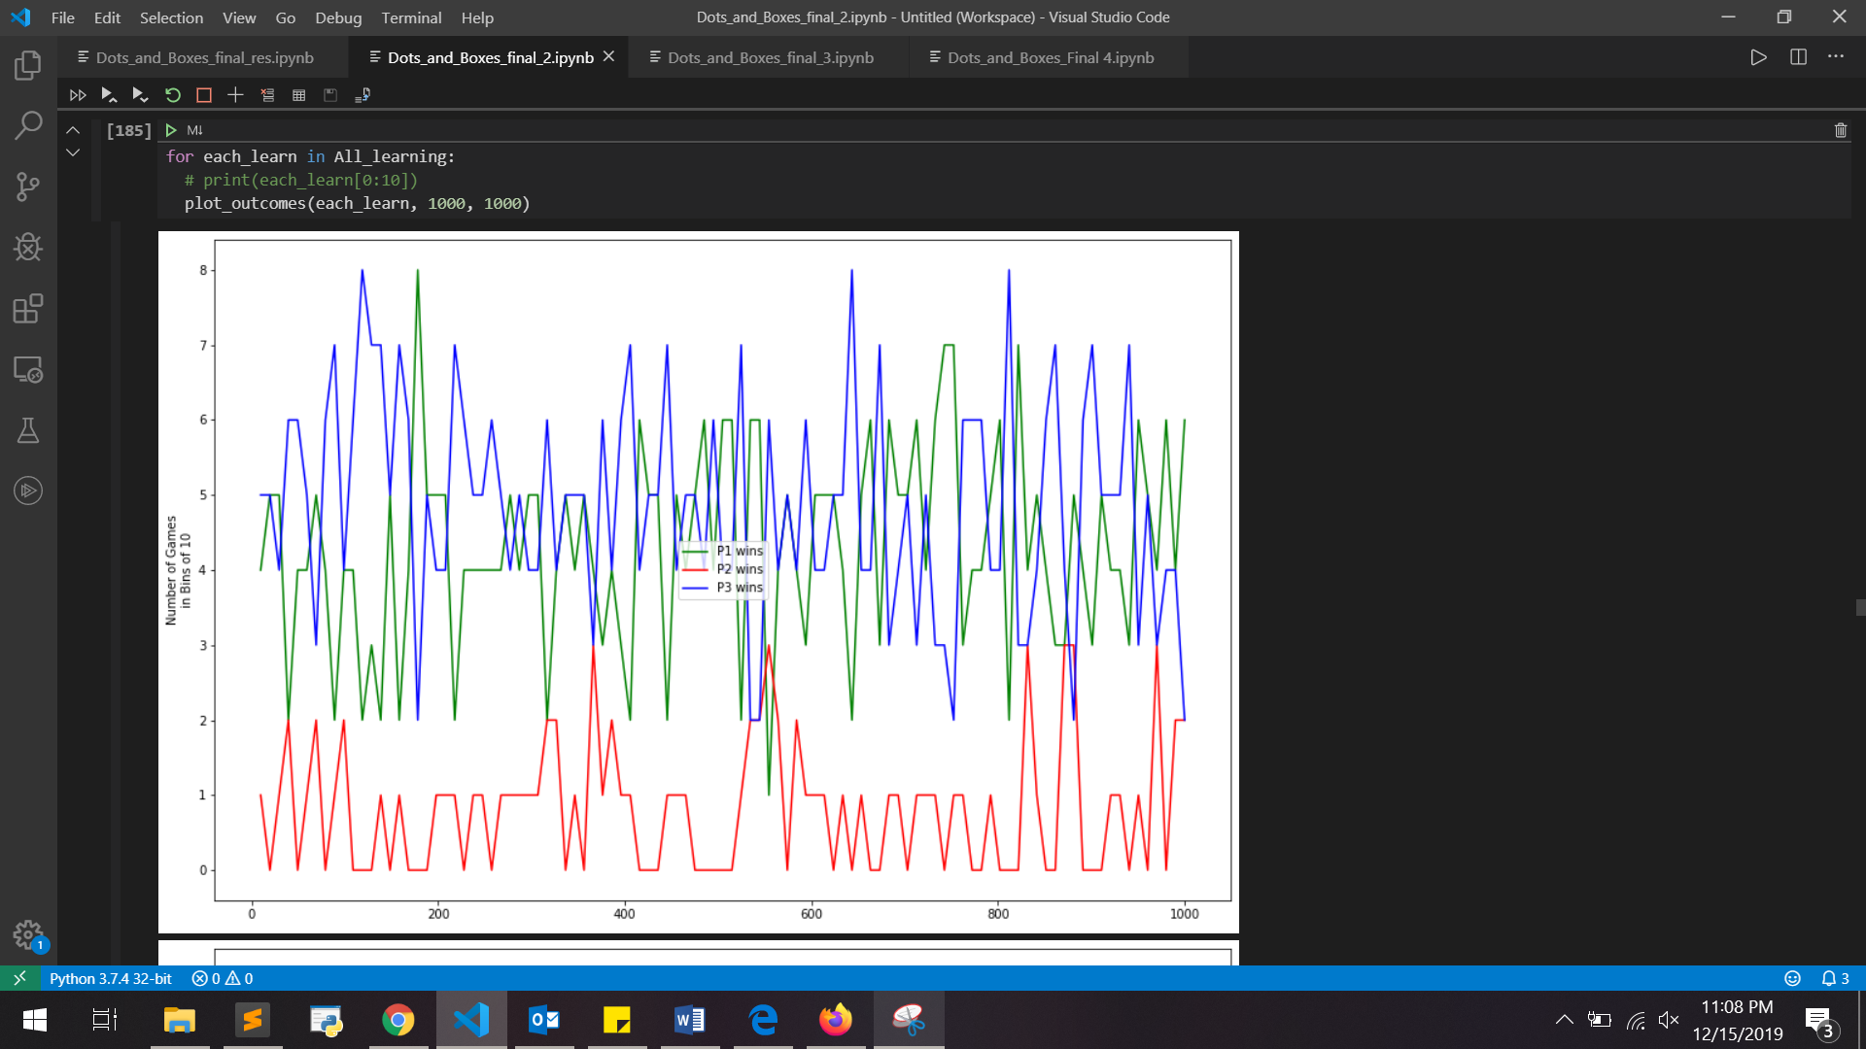

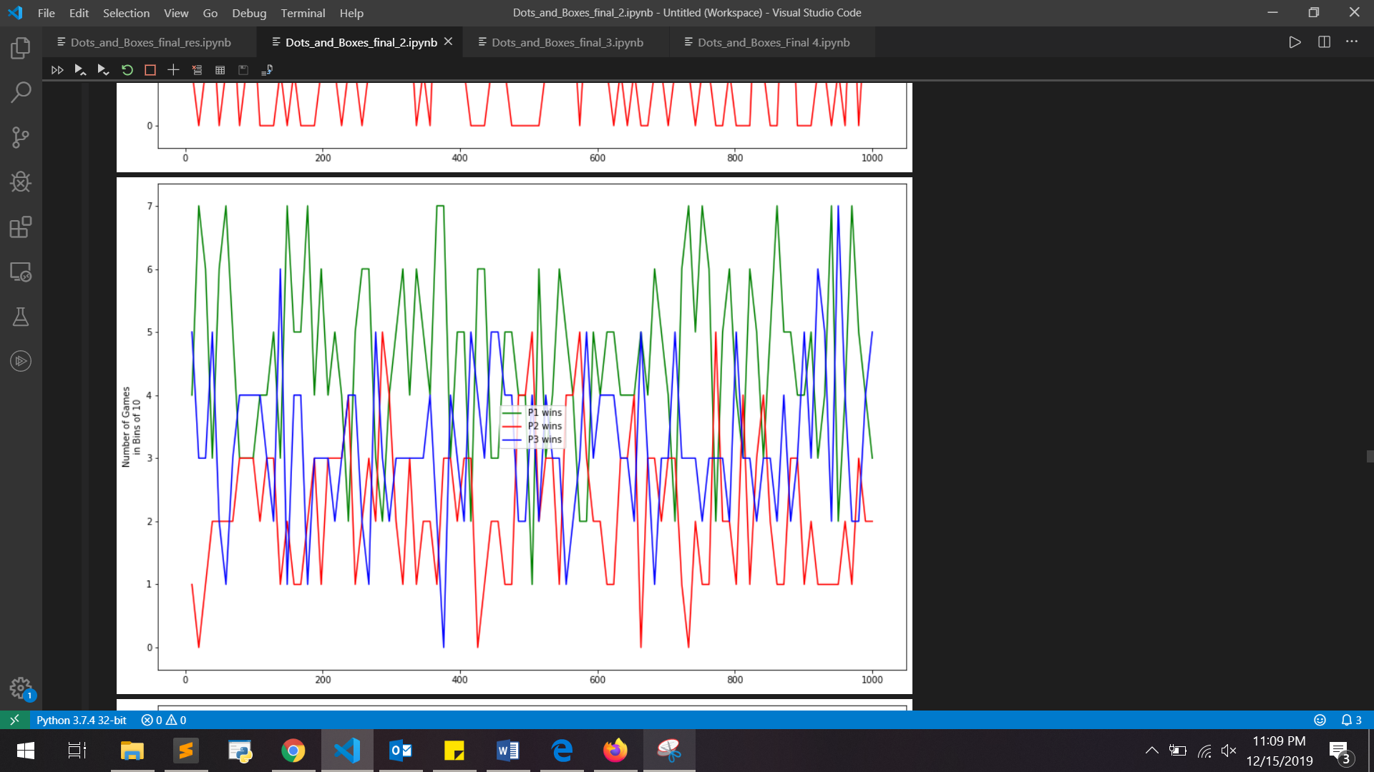

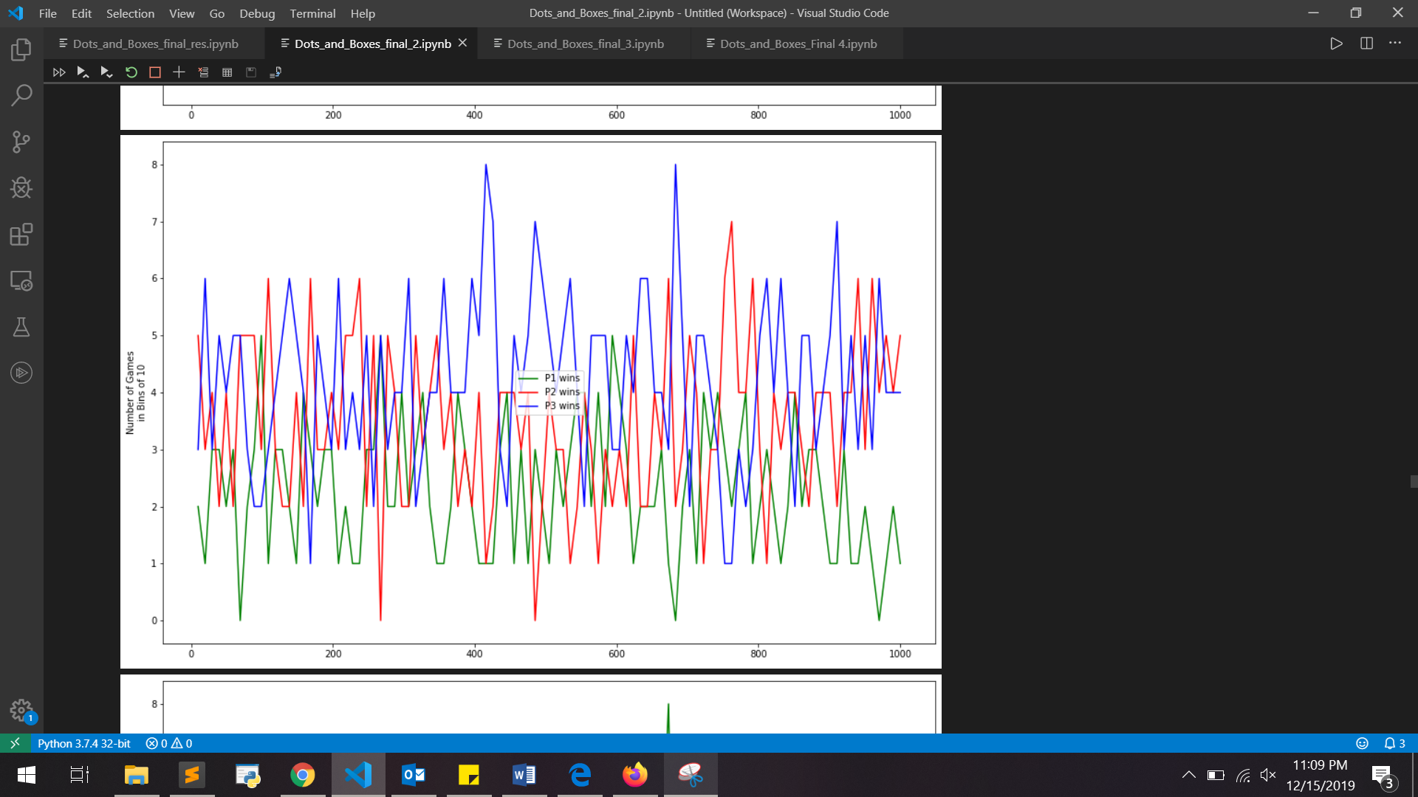

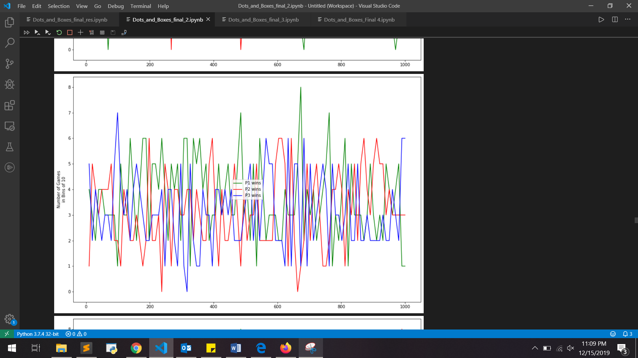

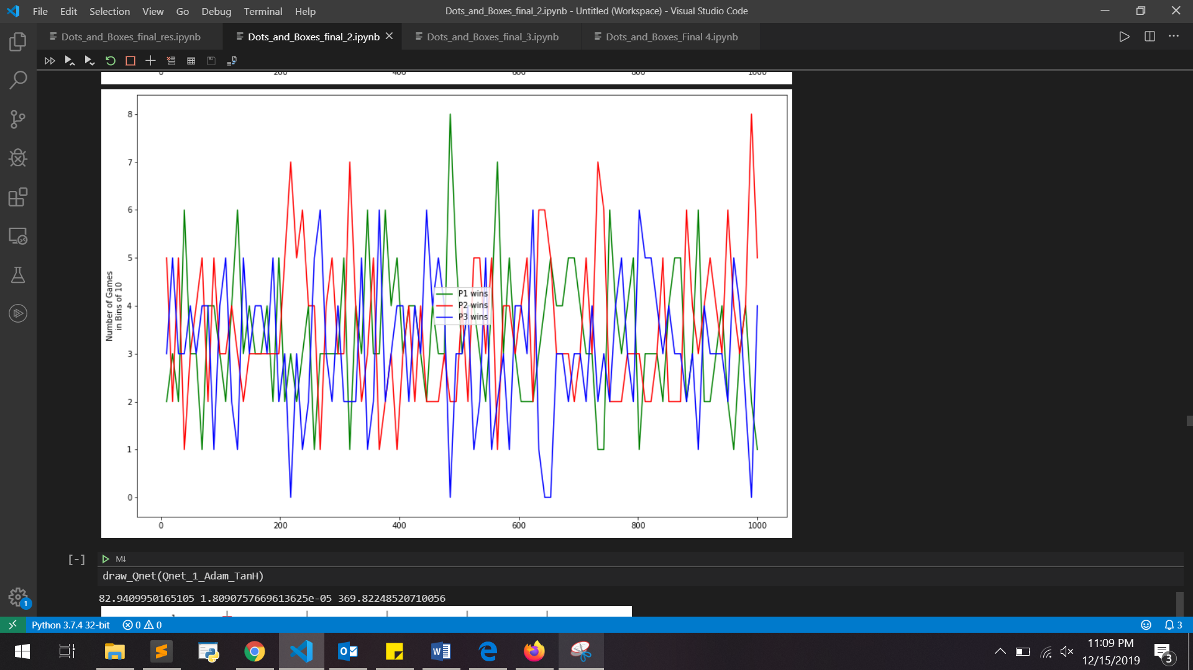

**Configuration 3 - Pranav Kulkarni – pjkulkar**

Model with SGD (Stochastic Gradient descent algorithm) & Tanh (Activation function):

n_batches = 40

n_reps_per_batch = 2000

n_iterations = 160

network = [2*rows+cols,cols]

learning_rate = 0.025

Game sizes: [2x2, 3x2, 3x3, 4x3, 4x4]

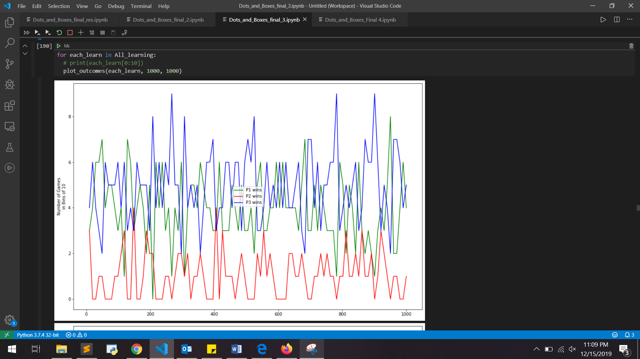

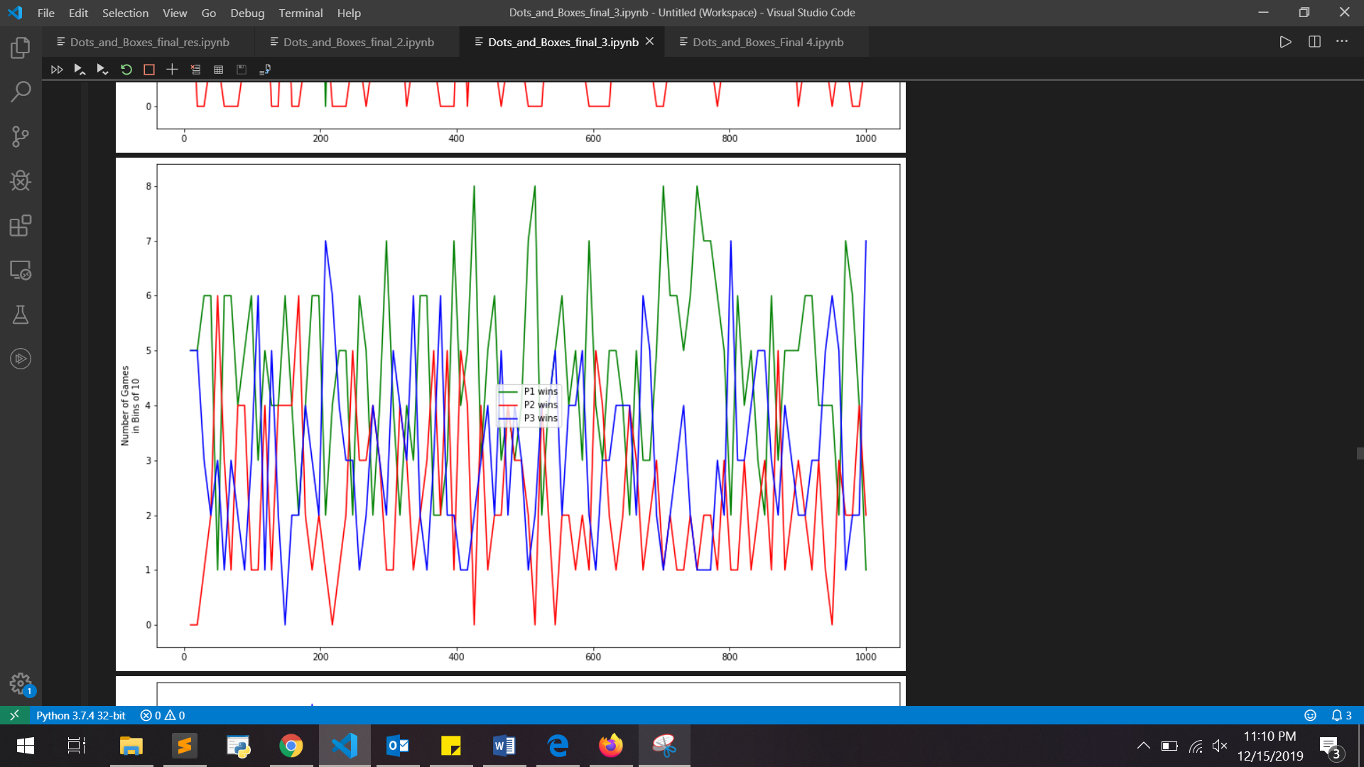

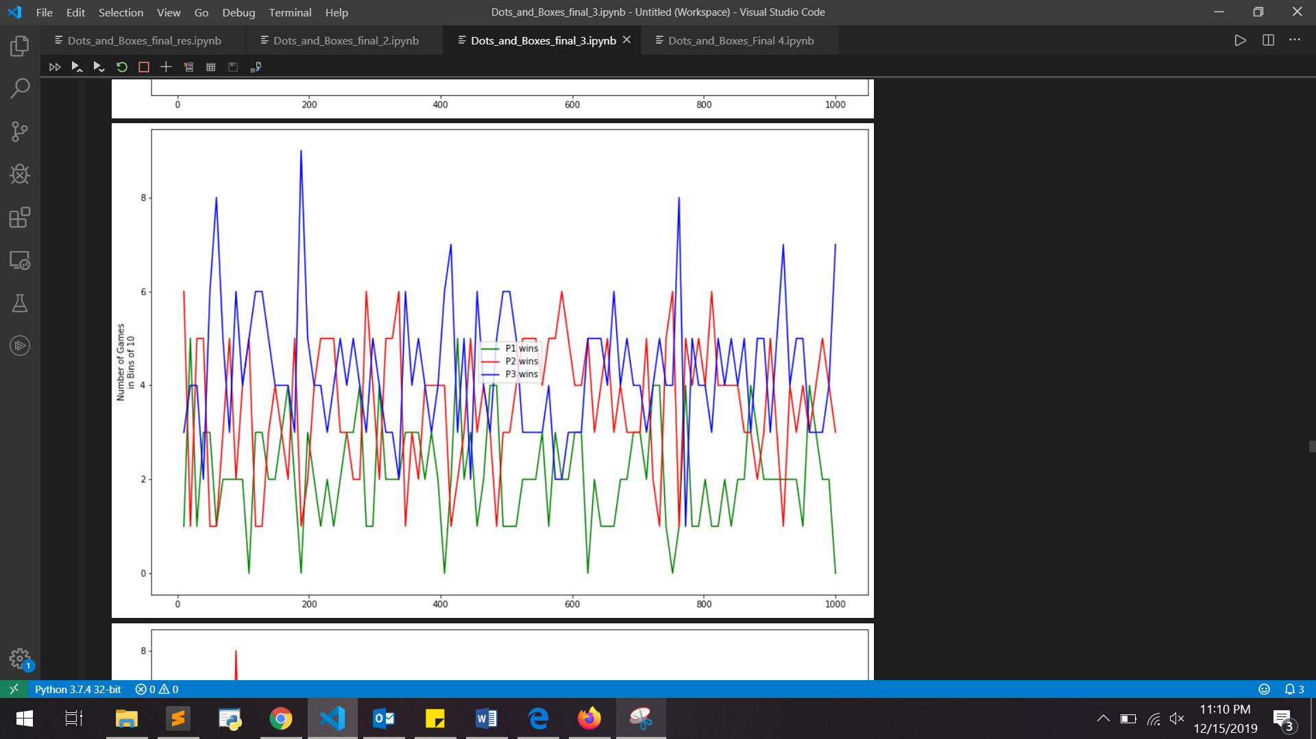

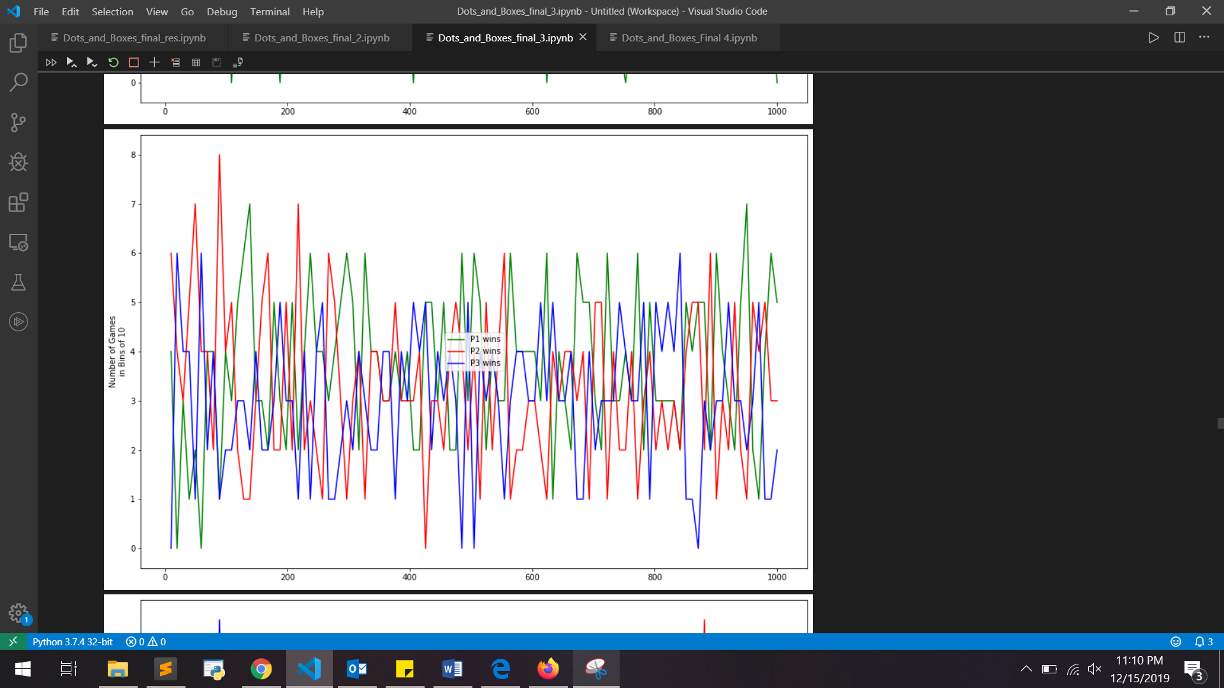

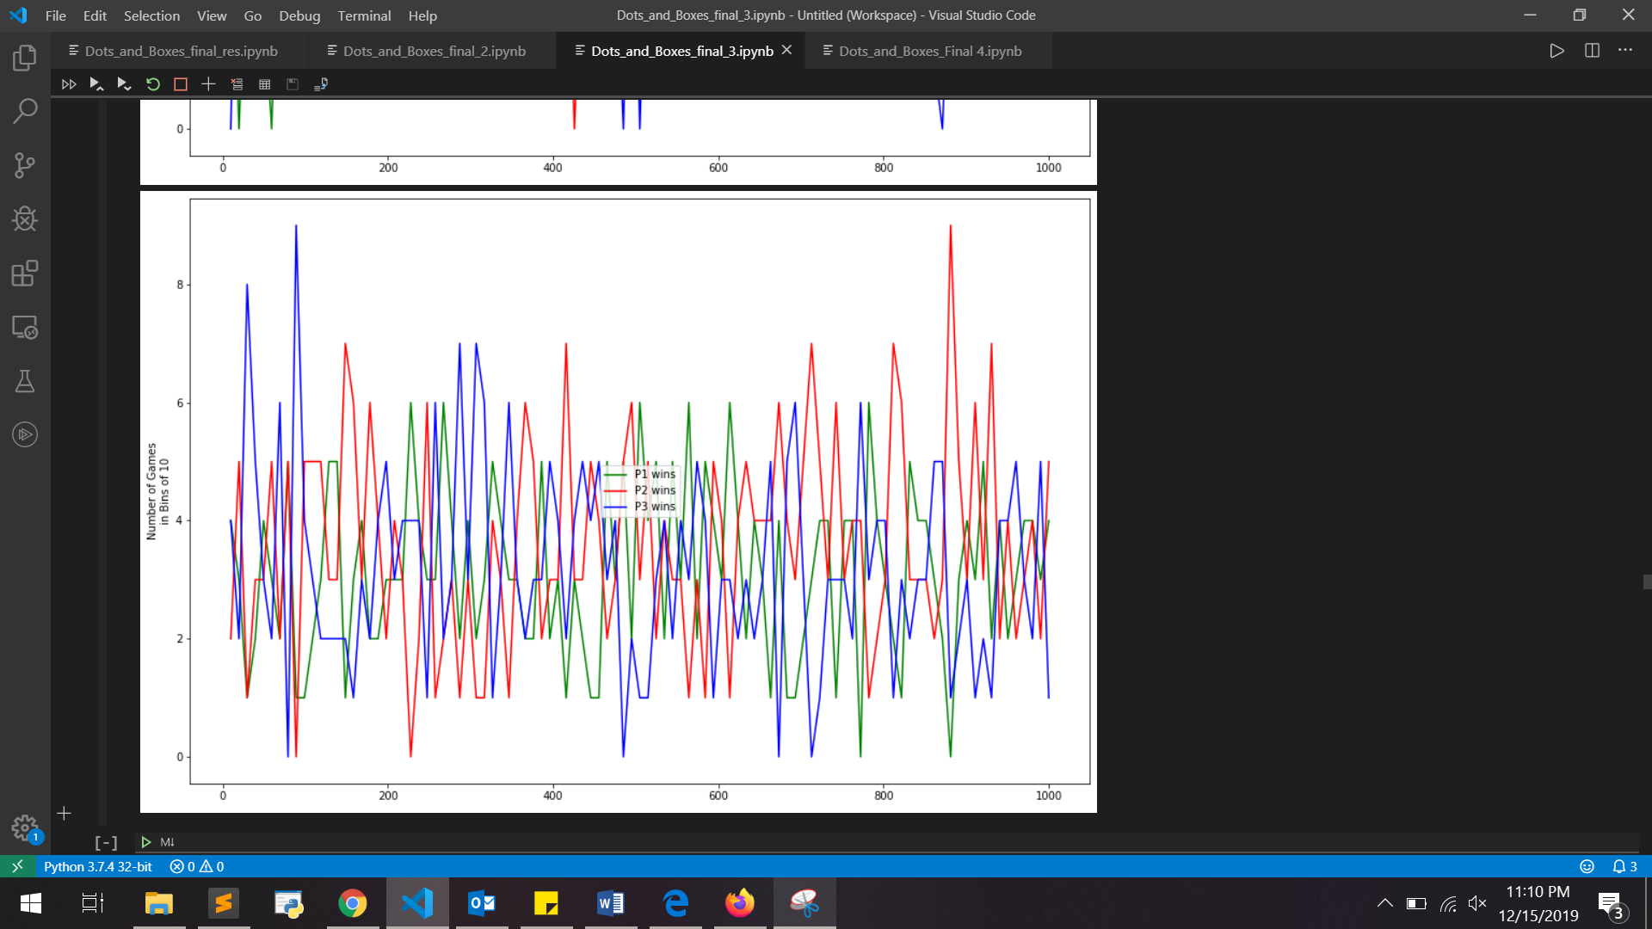

**Configuration 4 - Sreekar Sykam Reddy – ssykam**

Model with SGD (Stochastic Gradient descent algorithm) & ReLU(Rectified Linear Unit for activation function):

n_batches = 30

n_reps_per_batch = 1500

n_iterations = 125

network = [2*(rows+cols),cols]

learning_rate = 0.02

Game sizes: [2x2, 3x2, 3x3, 4x3, 4x4]

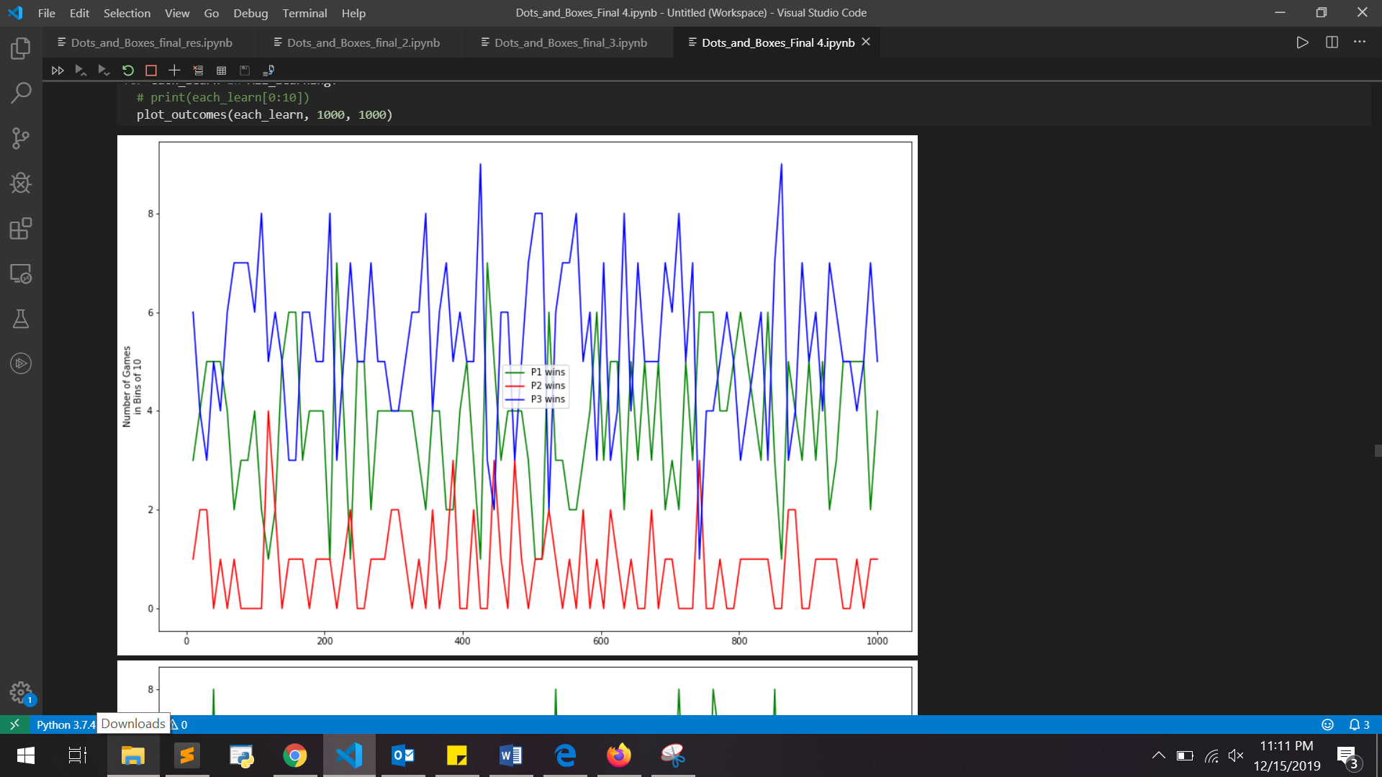

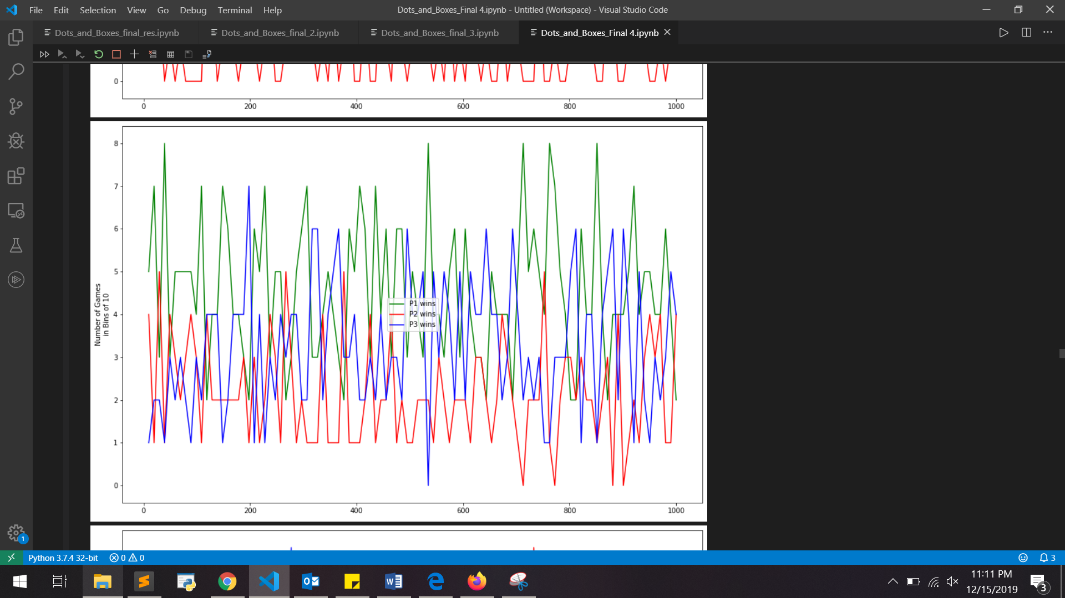

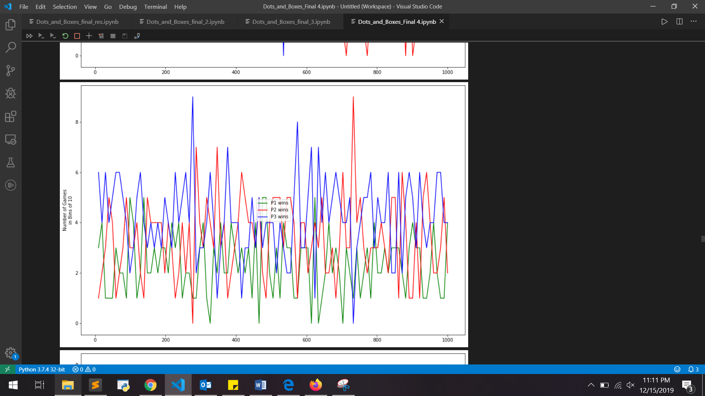

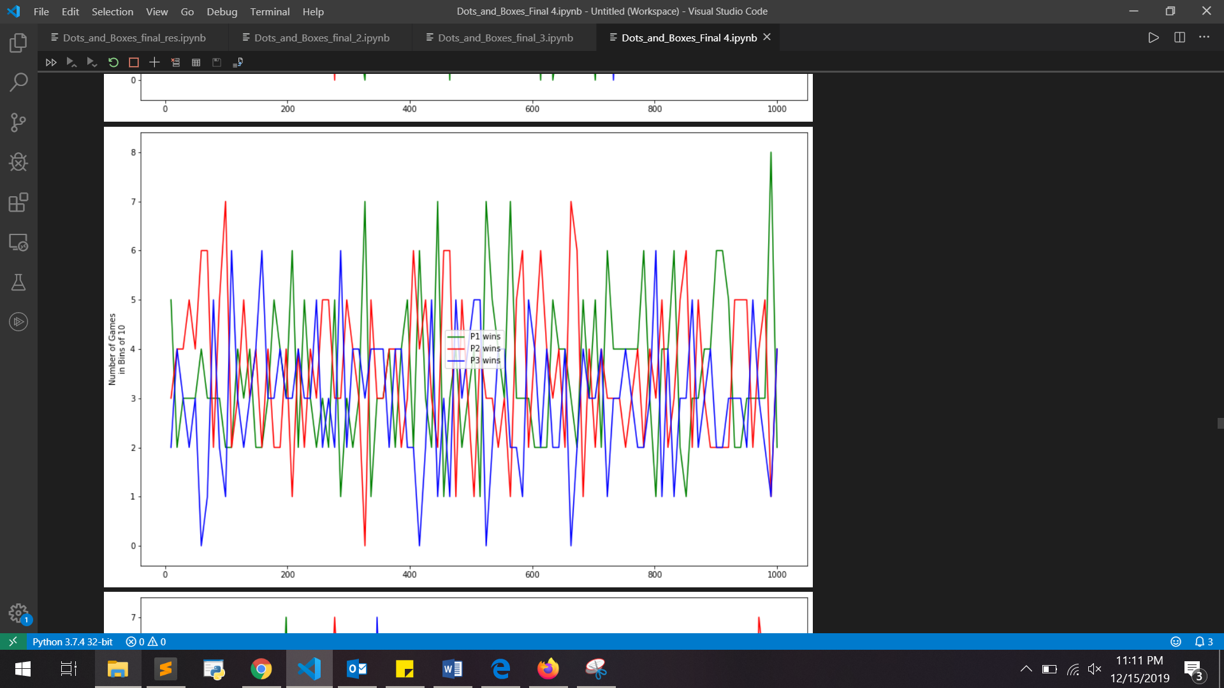

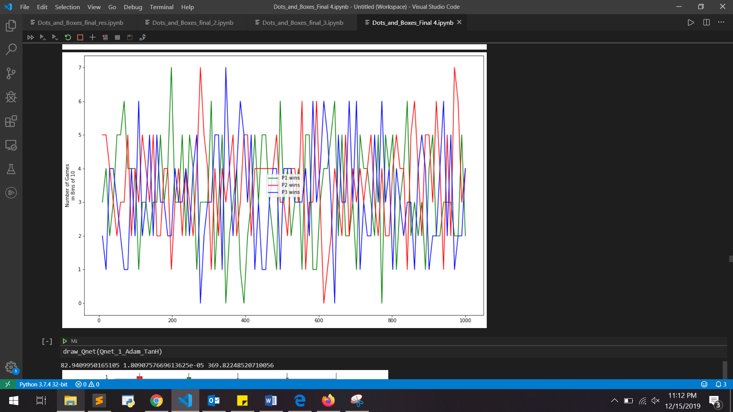

**Conclusion:**

**Bibliography:**

[1]Dots and Boxes. (2019, November 18). Retrieved from https://en.wikipedia.org/wiki/Dots_and_Boxes.

[2] Minimax Algorithm in Game Theory: Set 1 (Introduction). (2019, May 28). Retrieved from https://www.geeksforgeeks.org/minimax-algorithm-in-game-theory-set-1-introduction/.